AI Powered Customer Support SLA & Escalation System
Make.com | Gmail | WhatsApp/Twilio | HubSpot/SmartSuite | OpenAI/Claude | Notion | Slack | Google Drive | Google Sheets | Webhooks

Project Overview
Built an automated customer support and SLA management system for handling support requests across multiple communication channels.
The workflow takes a new customer request and turns it into a structured support ticket, including customer identification, issue classification, priority scoring, knowledge base research, response generation, escalation, SLA tracking, follow ups, and final resolution management.
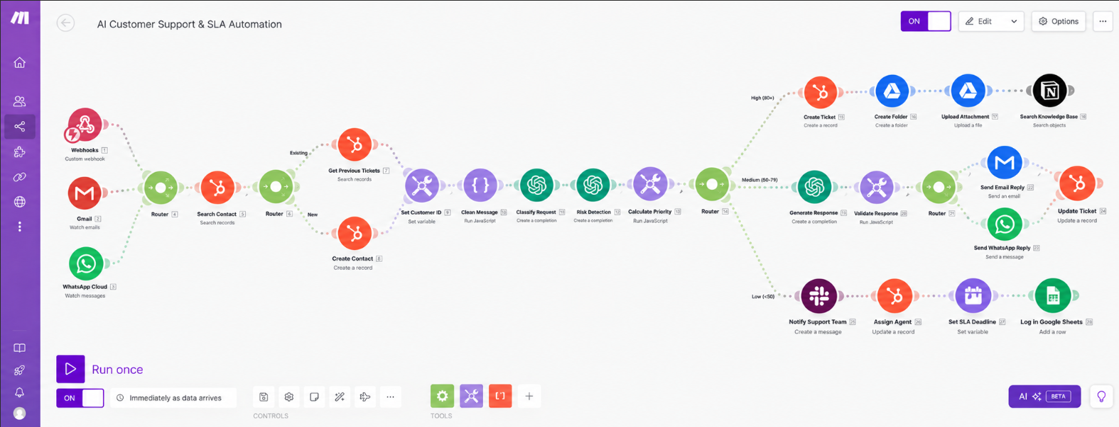
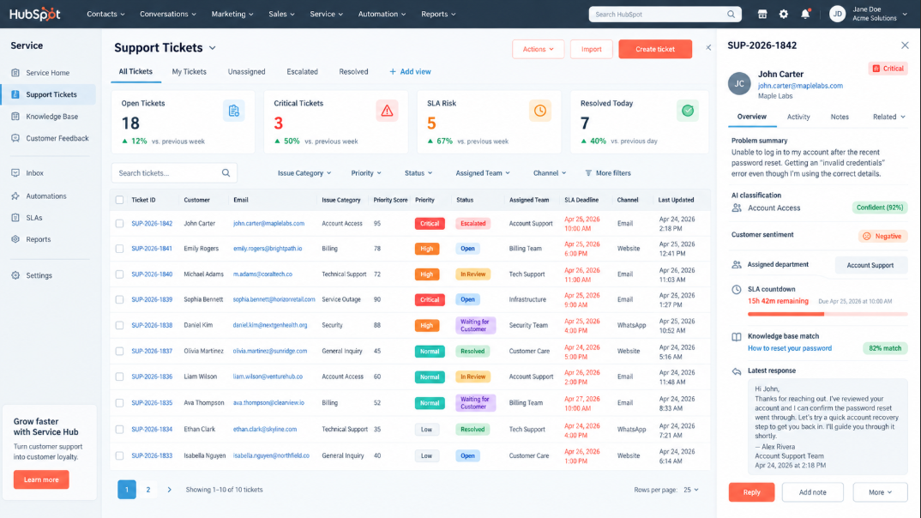
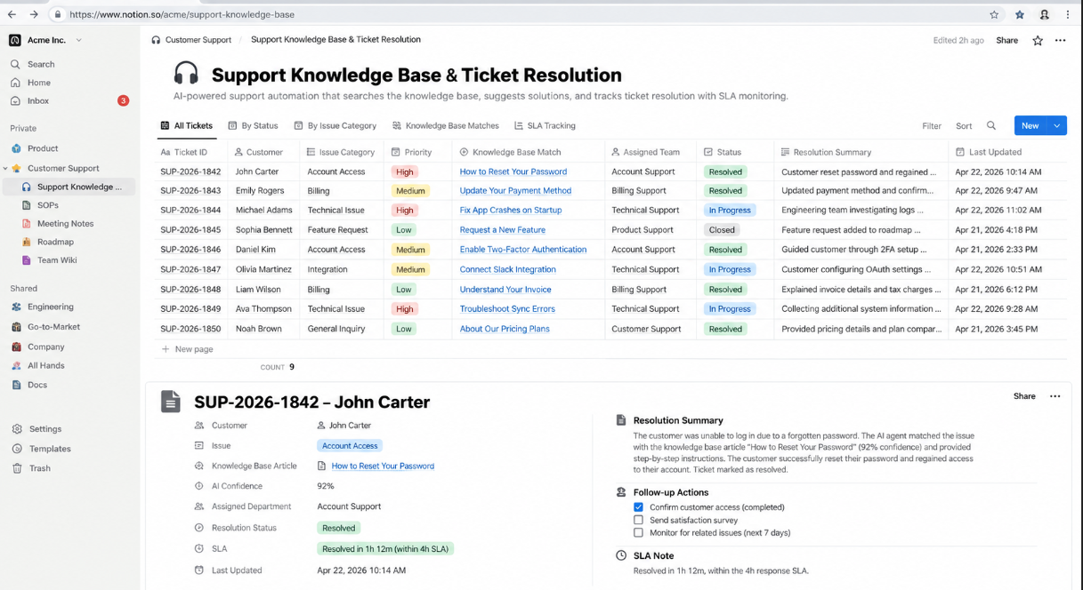
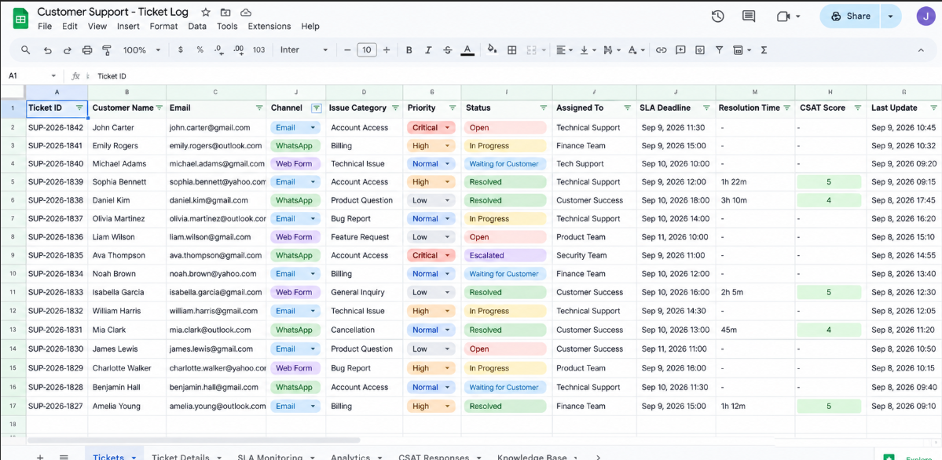

Workflow
The system:
- Receives customer support requests from website forms, Gmail, and WhatsApp
- Searches CRM records to identify existing customers
- Creates new customer records when required
- Retrieves previous support tickets and customer history
- Cleans and normalizes incoming customer messages
- Classifies support requests using AI
- Detects issue category, urgency, sentiment, language, and required department
- Identifies critical risks such as security issues, outages, legal complaints, and repeated unresolved problems
- Calculates a weighted priority score for every support request
- Routes tickets based on critical, normal, or low priority levels
- Creates structured support tickets automatically in the CRM
- Creates dedicated Google Drive folders for ticket attachments
- Uploads customer screenshots, PDFs, and supporting documents
- Searches the Notion knowledge base for relevant support information
- Evaluates whether the available knowledge is sufficient for an automated response
- Generates customer responses using AI and available support documentation
- Validates responses before sending them to customers
- Sends replies through Gmail or WhatsApp based on the original communication channel
- Sends uncertain tickets to the support team for human review
- Escalates critical support issues immediately through Slack
- Assigns tickets to the correct support department or agent
- Calculates SLA deadlines according to ticket priority
- Monitors open tickets for approaching SLA deadlines
- Sends SLA warning notifications to the support team
- Sends customer follow ups when responses remain pending
- Closes resolved tickets and generates AI resolution summaries
- Sends customer satisfaction requests after successful resolution
- Updates support analytics and operational records automatically

Branding & Templates
The workflow uses predefined support, escalation, response, and SLA templates throughout the customer service process.
Each template controls:
- Customer response format
- Support communication tone
- Escalation rules
- SLA priority requirements
- Follow up messaging
This keeps support communication consistent while allowing every ticket to be handled according to its issue type, priority, and customer history.

Content Management
HubSpot or SmartSuite acts as the central customer support database and ticket tracking system.
Each processed ticket is updated with:
- Customer information
- Issue category
- Priority score
- Support status
- SLA deadline
- Assigned team
- Response history
- Resolution summary
- Customer satisfaction status

Technology
- Make.com
- Gmail
- WhatsApp/Twilio
- HubSpot/SmartSuite
- OpenAI/Claude
- Notion
- Slack
- Google Drive
- Google Sheets
- Webhooks

Result
A complete automated customer support pipeline that turns a customer request into an identified, classified, prioritized, assigned, tracked, and resolved support ticket without requiring support teams to manually manage every step.
The system also keeps customer history, ticket records, attachments, AI responses, SLA deadlines, escalations, resolution summaries, and support analytics organized in one workflow.

